PROGRAM 5: BREADTH FIRST SEARCH (BFS)
Aim
To write a Python program to implement Breadth First Search (BFS) traversal of a graph.

Objective
To traverse all the vertices of a graph level by level using the BFS algorithm.

Algorithm
- Start.
- Create a graph using an adjacency list.
- Mark all vertices as unvisited.
- Insert the starting vertex into a queue.
- Remove a vertex from the queue and print it.
- Add all unvisited adjacent vertices to the queue.
- Repeat until the queue becomes empty.
- Stop.

Source Code
graph = {
'A': ['B', 'C'],
'B': ['D', 'E'],
'C': ['F'],
'D': [],
'E': [],
'F': []
}

visited = []
queue = []

visited.append('A')
queue.append('A')

while queue:
node = queue.pop(0)
print(node, end=" ")

for i in graph[node]:
if i not in visited:
visited.append(i)
queue.append(i)
Flowchart
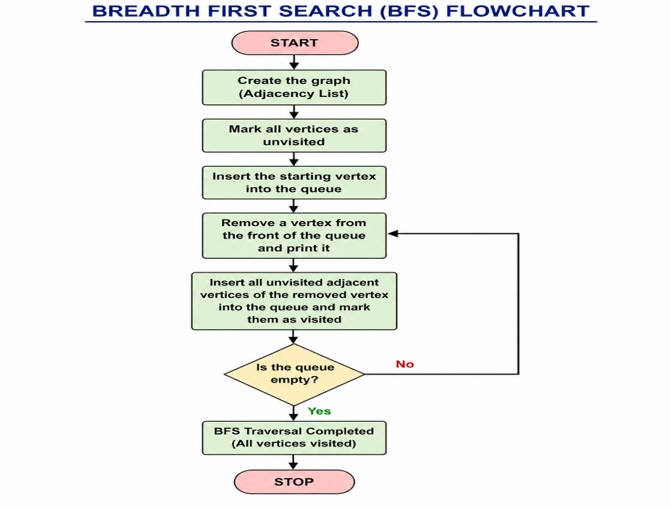

Sample Output
BFS Traversal:

A B C D E F
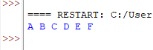
Result
Thus, the Python program to implement Breadth First Search (BFS) was executed successfully.

